Steps to add the angular universal:

1. Create a new project
2. Then run the following command :

* **ng add @nguniversal/express-engine**

1. You can refer the below link and github repo for reference:

<https://trilon.io/blog/angular-universal-v9-whats-new>

<https://github.com/TrilonIO/angular-universal-v9>

1. If you get the localStorage not define or error of localStorage, do that following things

* Install the package **localstorage-pollyfill**
* Like **npm i localstorage-pollyfill**
* Then import the library in **server.ts or server.js** file, which ever present in your app.

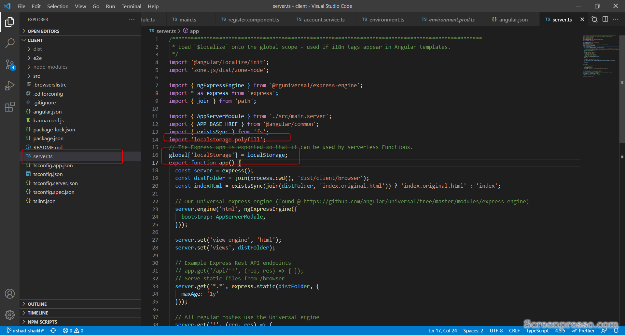

1. One other issue was there with event-emitter, it was directly imported from the events package in guest component, but needs to be imported from @angulart/core

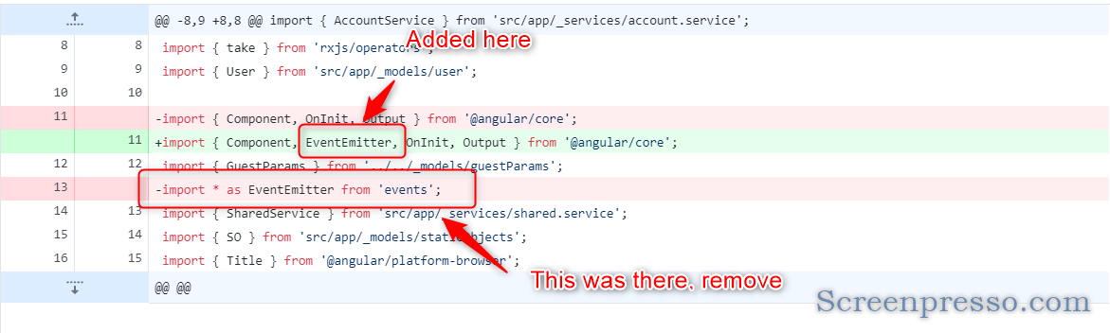

1. 1 small issue with calling the function from component.

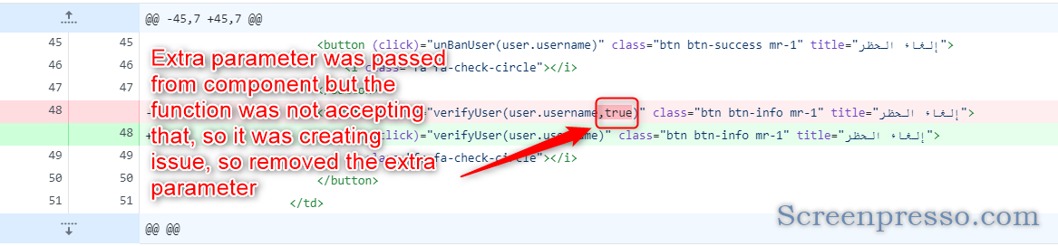

1. Issue in accessing the flat method in array in error interceptor, so fixed that my introducing the any method, so it can work.

